Cal Newport
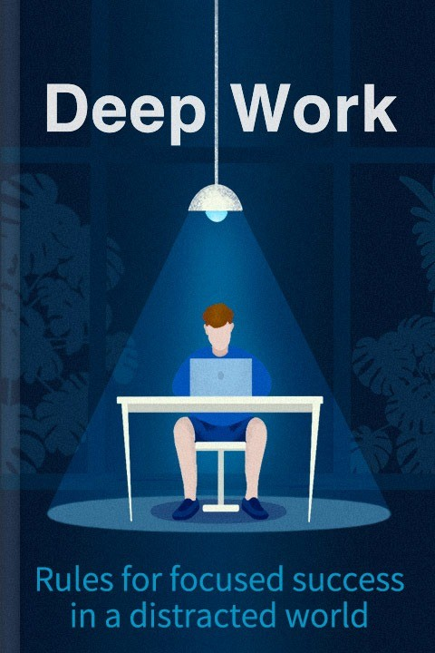
Deep Work
Master Focus to Unlock Your Full Potential in a Distracted World.
Written by Bookey
Check more about Deep Work Summary
Listen Deep Work Audiobook

